EWMA correlation: USDCAD and EURGBP
Method 06 / daily log returns / lambda = 0.94 / Alpari D1 full available history

Study setup
Logical pair: USDCAD , EURGBP
Broker symbols: USDCAD_i , EURGBP_i
Snapshot: 2026-11-03_majors_alpari_D1
Timeframe: D1
Matched return window: 1999-01-06 to 2026-11-02 (UTC bar dates)
Matched return count n: 7185
Dropped unfinished last bar dated 2026-11-03 UTC after a tick-volume check against the prior complete day.
Lambda: 0.94 (today weight 0.06)
Burn-in ignored in path summaries and chart: first 60 updates
Mean adjustment: each leg demeaned by its mean on the matched rows
Seeds: c_0 = v_x,0 = v_y,0 = 0
Complete matched rows (Excel): USDCAD-EURGBP_EWMA_D1.xlsx
Complete matched rows (HTML table): USDCAD-EURGBP_EWMA_D1_data.html

Method carried forward
EWMA correlation updates covariance and variances of mean-adjusted daily log returns of close, ln(close_t / close_t-1), with lambda = 0.94 (6% weight on today's product or square, 94% on yesterday's EWMA state). Quotes are not inverted. Each leg is demeaned by its mean on the matched rows; that mean uses the full sample, so the rho path is a full-sample description, not a live filter. Seeds start at zero. Path summaries and the chart ignore the first 60 updates so the zero seed has faded. The headline is rho on the last day. rho is symmetric under swap of the two symbols. A high |rho| does not prove cause, lead-lag, or a trading signal. Today's return sits inside today's rho, so the estimate can only inform a later decision. Same-sample Pearson r is a side check only.

Results
Latest EWMA rho: 0.093336
Post-burn-in path (n=7125): mean=-0.026018, median=-0.033531, min=-0.672547, max=0.684609, std=0.243948
Share of post-burn-in days with |rho| >= 0.4: 10.47%; |rho| >= 0.7: 0.00%
Same-sample Pearson r: -0.014622
Latest rho minus r: 0.107957

Conclusion
Over 7185 matched daily log-return rows for USDCAD and EURGBP (broker quote directions unchanged), latest EWMA rho with lambda=0.94 is 0.0933 (positive, weak recent linear link in this sample). After a 60-day burn-in, path mean is -0.0260, std is 0.2439, and the range is [-0.6725, 0.6846]. Same-sample Pearson r is -0.0146 (latest rho minus r = 0.1080). This does not establish cause, lead-lag, or a lasting trading rule.

Charts
Daily closes

Daily log returns
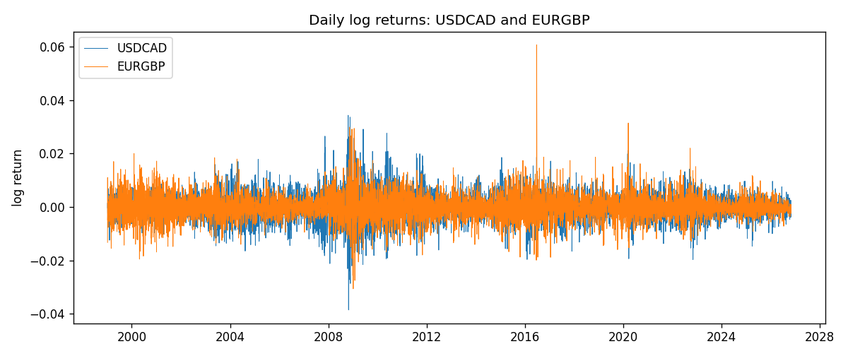
EWMA rho path with Pearson r reference
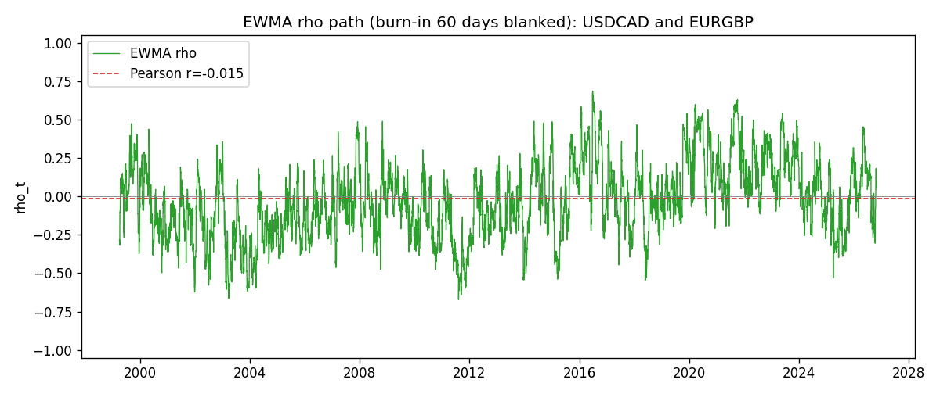

Data report
Every matched row that entered the EWMA recursion is stored in the sibling Excel workbook named USDCAD-EURGBP_EWMA_D1.xlsx. That file is the complete data archive for redrawing charts. Embedding all rows as a Word table is impractical at this length; the Word file holds the column list, column summaries, and the first and last 15 matched rows.
Columns: time, USDCAD_open, EURGBP_open, USDCAD_high, EURGBP_high, USDCAD_low, EURGBP_low, USDCAD_close, EURGBP_close, USDCAD_tick_volume, EURGBP_tick_volume, USDCAD_spread, EURGBP_spread, USDCAD_real_volume, EURGBP_real_volume, USDCAD_log_return, EURGBP_log_return, USDCAD_x_demeaned, EURGBP_y_demeaned, c_t, v_x, v_y, rho_t
Column summaries (matched calculation rows)
column | count | mean | std | min | 25% | 50% | 75% | max
USDCAD_open | 7185 | 1.2666594 | 0.16886861 | 0.9168 | 1.1183 | 1.29841 | 1.37203 | 1.6183
EURGBP_open | 7185 | 0.78693389 | 0.09666561 | 0.5734 | 0.6876 | 0.83387 | 0.86521 | 0.9769
USDCAD_high | 7185 | 1.2715589 | 0.16882635 | 0.9336 | 1.1227 | 1.30381 | 1.3764 | 1.619
EURGBP_high | 7185 | 0.79000929 | 0.09704455 | 0.5789 | 0.6896 | 0.8369 | 0.8681 | 0.9799
USDCAD_low | 7185 | 1.2621046 | 0.16891061 | 0.9056 | 1.11396 | 1.29347 | 1.36776 | 1.6102
EURGBP_low | 7185 | 0.78423344 | 0.09648411 | 0.5682 | 0.6855 | 0.83166 | 0.86287 | 0.9661
USDCAD_close | 7185 | 1.2666836 | 0.16885076 | 0.916 | 1.118 | 1.29833 | 1.3723 | 1.6137
EURGBP_close | 7185 | 0.78697576 | 0.09666885 | 0.5735 | 0.6878 | 0.83391 | 0.86533 | 0.977
USDCAD_tick_volume | 7185 | 81049.359 | 147325.09 | 37 | 5563 | 40946 | 71633 | 1410818
EURGBP_tick_volume | 7185 | 87109.869 | 145486.28 | 154 | 6553 | 44326 | 81375 | 1424684
USDCAD_spread | 7185 | 23.430202 | 18.259258 | 0 | 9 | 17 | 40 | 60
EURGBP_spread | 7185 | 21.335421 | 19.123862 | 0 | 4 | 13 | 40 | 50
USDCAD_real_volume | 7185 | 1.8384377e+10 | 9.670755e+10 | 0 | 0 | 0 | 0 | 2.5751613e+12
EURGBP_real_volume | 7185 | 2.7864528e+10 | 1.3519652e+11 | 0 | 0 | 0 | 0 | 3.5726265e+12
USDCAD_log_return | 7185 | -8.08e-06 | 0.00514591 | -0.03859748 | -0.00283484 | 5.597e-05 | 0.00272835 | 0.03436319
EURGBP_log_return | 7185 | 1.874e-05 | 0.00486681 | -0.03067367 | -0.00262366 | -0.00010035 | 0.00255918 | 0.06075387
USDCAD_x_demeaned | 7185 | -0 | 0.00514591 | -0.03858941 | -0.00282677 | 6.405e-05 | 0.00273643 | 0.03437126
EURGBP_y_demeaned | 7185 | 0 | 0.00486681 | -0.03069241 | -0.0026424 | -0.00011909 | 0.00254044 | 0.06073513
c_t | 7185 | -3.7e-07 | 8.02e-06 | -3.676e-05 | -3.66e-06 | -4.7e-07 | 2.05e-06 | 7.886e-05
v_x | 7185 | 2.646e-05 | 3.125e-05 | 1e-08 | 1.17e-05 | 1.801e-05 | 2.918e-05 | 0.00040855
v_y | 7185 | 2.368e-05 | 2.337e-05 | 1.89e-06 | 1.054e-05 | 1.818e-05 | 2.996e-05 | 0.00029344
rho_t | 7185 | -0.02450641 | 0.24430793 | -0.67254698 | -0.19916365 | -0.03181476 | 0.13911472 | 1
First 15 matched rows (selected columns)
time | USDCAD_close | EURGBP_close | USDCAD_log_return | EURGBP_log_return | USDCAD_x_demeaned | EURGBP_y_demeaned | c_t | v_x | v_y | rho_t
1999-01-06 | 1.5118 | 0.7019 | -0.0003306769 | -0.013303338 | -0.00032260184 | -0.013322077 | 2.578636e-07 | 6.244317e-09 | 1.0648664e-05 | 1
1999-01-07 | 1.5141 | 0.7097 | 0.0015202092 | 0.011051402 | 0.0015282842 | 0.011032663 | 1.2540544e-06 | 1.4600882e-07 | 1.7312923e-05 | 0.78875413
1999-01-08 | 1.511 | 0.7062 | -0.0020495197 | -0.004943862 | -0.0020414447 | -0.0049626013 | 1.7866637e-06 | 3.8729807e-07 | 1.7751793e-05 | 0.68139516
1999-01-11 | 1.5057 | 0.7053 | -0.0035137769 | -0.0012752393 | -0.0035057019 | -0.0012939785 | 1.9516421e-06 | 1.1014569e-06 | 1.6787148e-05 | 0.45386632
1999-01-12 | 1.5157 | 0.7077 | 0.0066194721 | 0.0033970309 | 0.0066275472 | 0.0033782916 | 3.1779308e-06 | 3.6708324e-06 | 1.646469e-05 | 0.40877598
1999-01-13 | 1.5226 | 0.708 | 0.0045420214 | 0.00042381861 | 0.0045500965 | 0.00040507939 | 3.0978439e-06 | 4.6927851e-06 | 1.5486654e-05 | 0.36338367
1999-01-14 | 1.5332 | 0.7066 | 0.0069376546 | -0.0019793588 | 0.0069457297 | -0.001998098 | 2.0792784e-06 | 7.3058077e-06 | 1.4796999e-05 | 0.19998237
1999-01-15 | 1.5245 | 0.7012 | -0.0056905671 | -0.0076715819 | -0.005682492 | -0.0076903211 | 4.576533e-06 | 8.8049022e-06 | 1.7457641e-05 | 0.36913188
1999-01-18 | 1.526 | 0.7017 | 0.00098344542 | 0.00071280921 | 0.00099152047 | 0.00069406999 | 4.3432321e-06 | 8.3355948e-06 | 1.6439087e-05 | 0.37102733
1999-01-19 | 1.5302 | 0.7007 | 0.002748513 | -0.0014261269 | 0.002756588 | -0.0014448661 | 3.8436641e-06 | 8.2913858e-06 | 1.5578e-05 | 0.33820189
1999-01-20 | 1.5211 | 0.7021 | -0.0059646885 | 0.0019960086 | -0.0059566134 | 0.0019772694 | 2.9063745e-06 | 9.9227772e-06 | 1.4877895e-05 | 0.23920167
1999-01-21 | 1.5146 | 0.7016 | -0.0042823796 | -0.00071240297 | -0.0042743046 | -0.00073114219 | 2.9194995e-06 | 1.0423591e-05 | 1.4017296e-05 | 0.24152806
1999-01-22 | 1.5184 | 0.7004 | 0.0025057712 | -0.0017118406 | 0.0025138462 | -0.0017305799 | 2.4833048e-06 | 1.0177341e-05 | 1.3355952e-05 | 0.21299795
1999-01-25 | 1.5197 | 0.6966 | 0.00085579808 | -0.0054402425 | 0.00086387314 | -0.0054589817 | 2.0513545e-06 | 9.6114774e-06 | 1.4342624e-05 | 0.17471546
1999-01-26 | 1.52 | 0.6962 | 0.0001973879 | -0.00057438255 | 0.00020546295 | -0.00059312177 | 1.9209613e-06 | 9.0373217e-06 | 1.3503174e-05 | 0.17389249
Last 15 matched rows (selected columns)
time | USDCAD_close | EURGBP_close | USDCAD_log_return | EURGBP_log_return | USDCAD_x_demeaned | EURGBP_y_demeaned | c_t | v_x | v_y | rho_t
2026-10-13 | 1.4214 | 0.84458 | -0.0046395653 | 0.00020130374 | -0.0046314902 | 0.00018256452 | -1.2644774e-06 | 7.2120838e-06 | 2.6710374e-06 | -0.2880983
2026-10-14 | 1.42356 | 0.84553 | 0.0015184751 | 0.0011241873 | 0.0015265501 | 0.0011054481 | -1.0873574e-06 | 6.91918e-06 | 2.5840961e-06 | -0.25715246
2026-10-15 | 1.41843 | 0.84479 | -0.0036101503 | -0.00087557391 | -0.0036020753 | -0.00089431313 | -8.2883298e-07 | 7.282526e-06 | 2.4770381e-06 | -0.195146
2026-10-16 | 1.41357 | 0.84307 | -0.0034322068 | -0.0020380844 | -0.0034241317 | -0.0020568237 | -3.5653289e-07 | 7.5490551e-06 | 2.5822472e-06 | -0.080752206
2026-10-19 | 1.41091 | 0.84259 | -0.0018835331 | -0.00056950988 | -0.001875458 | -0.0005882491 | -2.6894673e-07 | 7.3071524e-06 | 2.4480746e-06 | -0.063588687
2026-10-20 | 1.40569 | 0.83957 | -0.0037066008 | -0.0035906254 | -0.0036985258 | -0.0036093647 | 5.4814977e-07 | 7.6894688e-06 | 3.0828409e-06 | 0.1125837
2026-10-21 | 1.4045 | 0.83839 | -0.00084691787 | -0.00140647 | -0.00083884282 | -0.0014252092 | 5.8699238e-07 | 7.2703201e-06 | 3.0197437e-06 | 0.1252768
2026-10-22 | 1.40081 | 0.83682 | -0.0026307268 | -0.0018743924 | -0.0026226518 | -0.0018931316 | 8.4967434e-07 | 7.2467991e-06 | 3.053596e-06 | 0.18062323
2026-10-23 | 1.40085 | 0.83751 | 2.85545e-05 | 0.00082421033 | 3.6629554e-05 | 0.00080547111 | 8.0046412e-07 | 6.8120716e-06 | 2.9093072e-06 | 0.17980736
2026-10-26 | 1.40093 | 0.83762 | 5.7106554e-05 | 0.00013133309 | 6.5181607e-05 | 0.00011259387 | 7.5287662e-07 | 6.4036023e-06 | 2.7355094e-06 | 0.179884
2026-10-27 | 1.40449 | 0.83595 | 0.0025379458 | -0.0019957343 | 0.0025460208 | -0.0020144736 | 3.9997052e-07 | 6.4083194e-06 | 2.8148651e-06 | 0.094173154
2026-10-28 | 1.39911 | 0.83651 | -0.0038379274 | 0.00066967224 | -0.0038298523 | 0.00065093302 | 2.2639365e-07 | 6.9038864e-06 | 2.671396e-06 | 0.052716708
2026-10-29 | 1.39895 | 0.83553 | -0.00011436495 | -0.0011722209 | -0.0001062899 | -0.0011909601 | 2.2040525e-07 | 6.4903311e-06 | 2.5962154e-06 | 0.05369306
2026-10-30 | 1.39751 | 0.83351 | -0.0010298736 | -0.0024205543 | -0.0010217985 | -0.0024392935 | 3.5672893e-07 | 6.1635555e-06 | 2.7974517e-06 | 0.085909537
2026-11-02 | 1.39837 | 0.83426 | 0.00061519094 | 0.00089940465 | 0.000623266 | 0.00088066543 | 3.6825852e-07 | 5.8170498e-06 | 2.6761389e-06 | 0.09333555

